COLD ASHBY VILLAGE HALL
Main Street, Cold Ashby NN6 6EL
Charity number 1024816
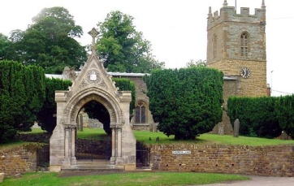
Committee Meeting

Tuesday 21st May, 2019: 7.30 p.m.

Agenda

- Minutes of meeting on 19th February 2019
- Matters arising:
- Apologies for absence
- Chairman’s report: matters for the committee’s attention
- Finance:
- Monthly accounts March-May
- £30 lottery loss
- Electricity improvements
- Activities and usage update:
- Luncheon club (CS)
- Cycling – polling station
- Centenary activities 2020
- AOB

G Jones, Secretary May 2019

